LAB 4
Static NAT
Sơ đồ:

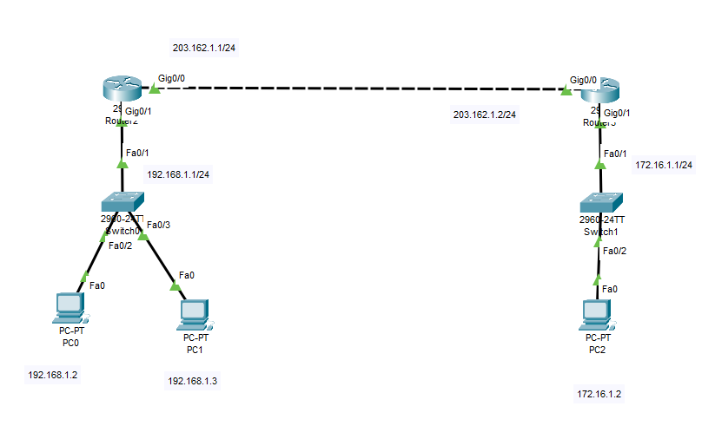
Setup:
Router1:
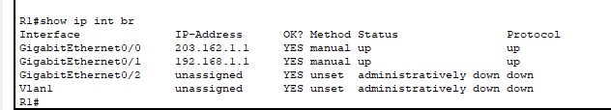
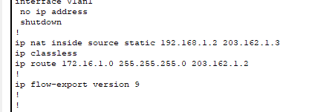

Router2:
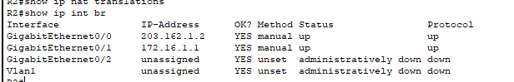
Result:
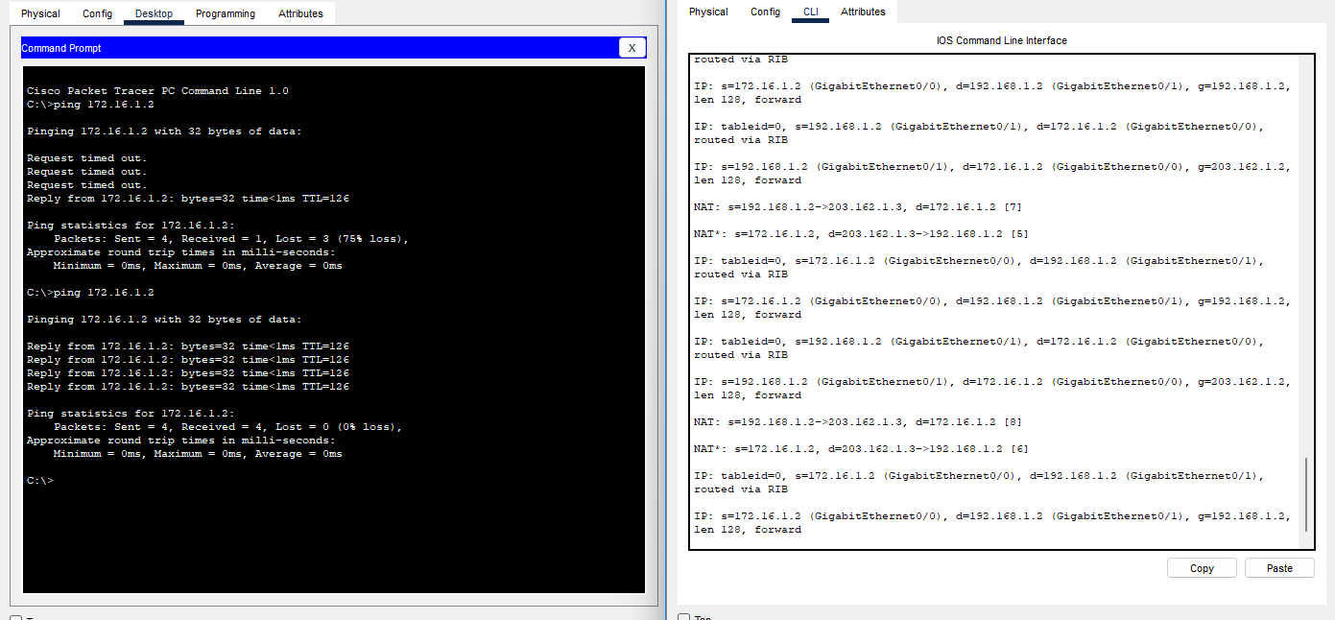

Dynamic NAT
Sơ đồ:
Setup:
Router 1:
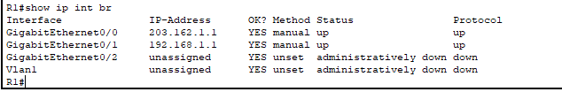
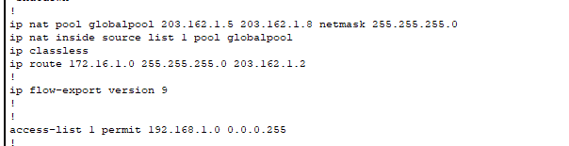
Router 2:
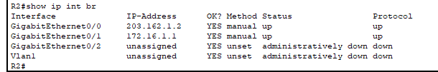
Result:
PC0:
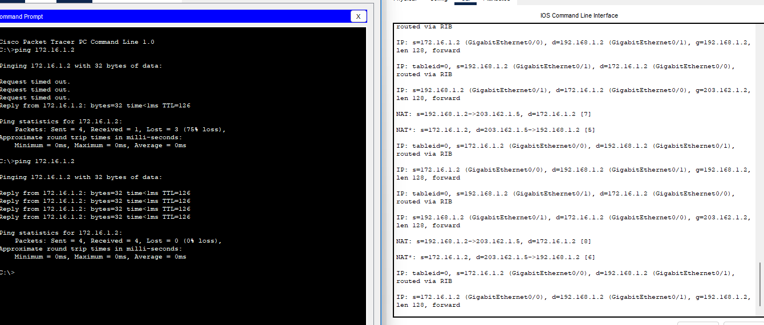
PC1:
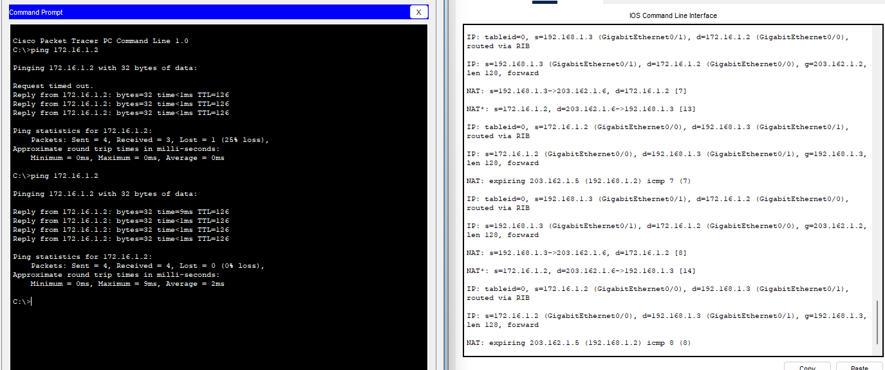

Dynamic NAT Overload
Sơ đồ:

Setup:
Router 1:
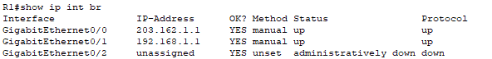
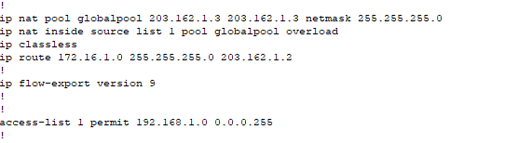
Router 2:
Result:
PC0:
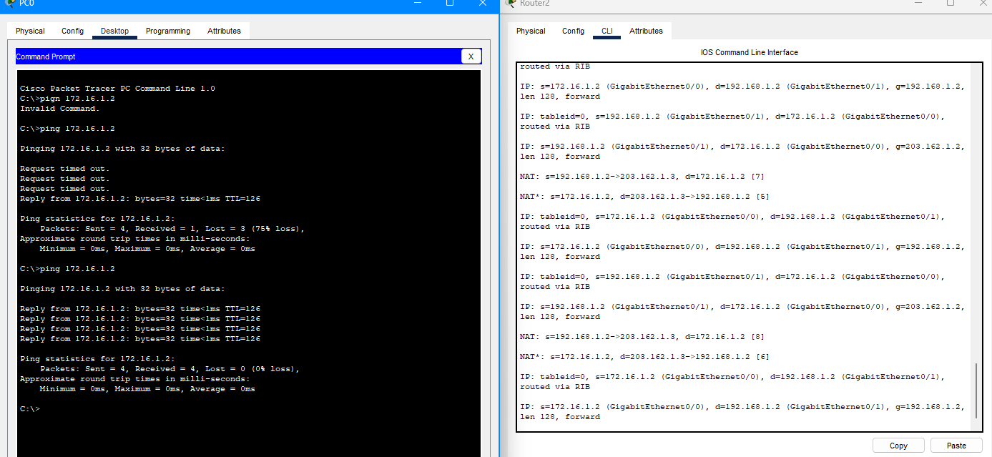

PC1:
